Your task is to create a web application that meets the following requirements:

1. Design Bottom Tab to show Home, City Expert, Saved, Investor and Profile.   
   **Note** : City Expert, Investor and Profile will be empty screen.
2. Implement Flashlist/Flatlist to render properties in home screen.  
   Design Property Card As per Screenshot. Implement infinite scroll on List. Add pagination on every 6 Card with API.
3. Saved Card : use redux to saved card when click on heart icon. Saved property will be shown in Saved Screen. When again click on saved it will unsaved property.
4. You Need to show Filter Options Filter,Types Of Property and BHK Type. **NOTE:** It will just for show in design you don’t need implement any logic there.



**Requirements :**

* Use Axios or other library to call API.
* Use Redux store saved or unsaved properties.
* useCallback and useMemo function accordingly to avoid re-rendering.
* Follow best practices for code organization, readability, and maintainability.

**Related to Task**

You need to use this api for listing all the cards:

You will find all the data required for building the application from the below API.

[**https://api.housivity.com/api/v1/property**](https://api.housivity.com/api/v1/property?city=Gandhinagar&projectType=%5B%22pgHostel%22%5D&page=1)

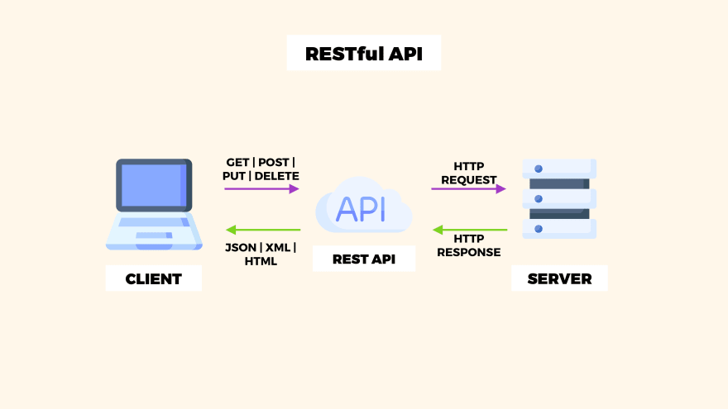

**Query Params:**

**City**:Gandhinagar (type string)

**projectType**:pgHostel (type array)

**page** (for pagination-type number)

You will find all the assets required for building the application from the below drive link.

[**https://drive.google.com/drive/folders/1XoajnIcQyJ_HBMl8NfeakXJfe_AcixHQ?usp=sharing**](https://drive.google.com/drive/folders/1XoajnIcQyJ_HBMl8NfeakXJfe_AcixHQ?usp=sharing)

The final application should resemble this design:

**Home Screen**

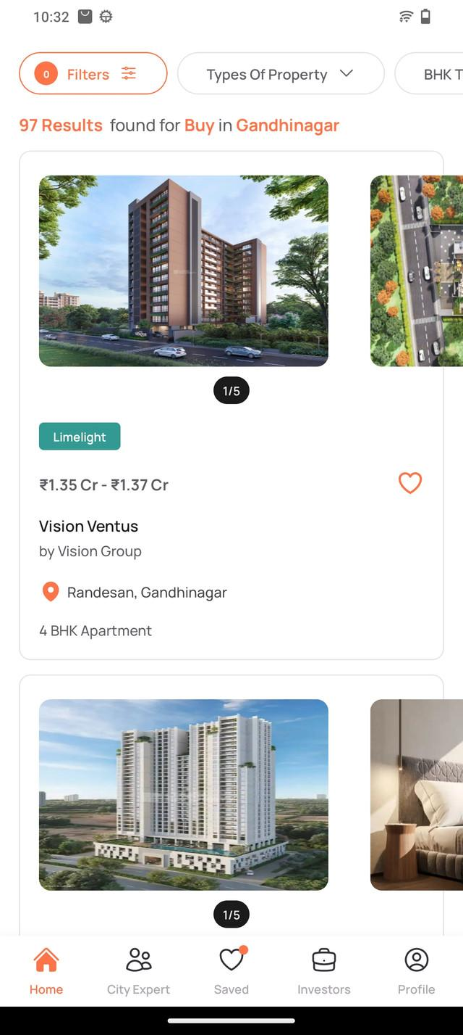

**Saved Card :**

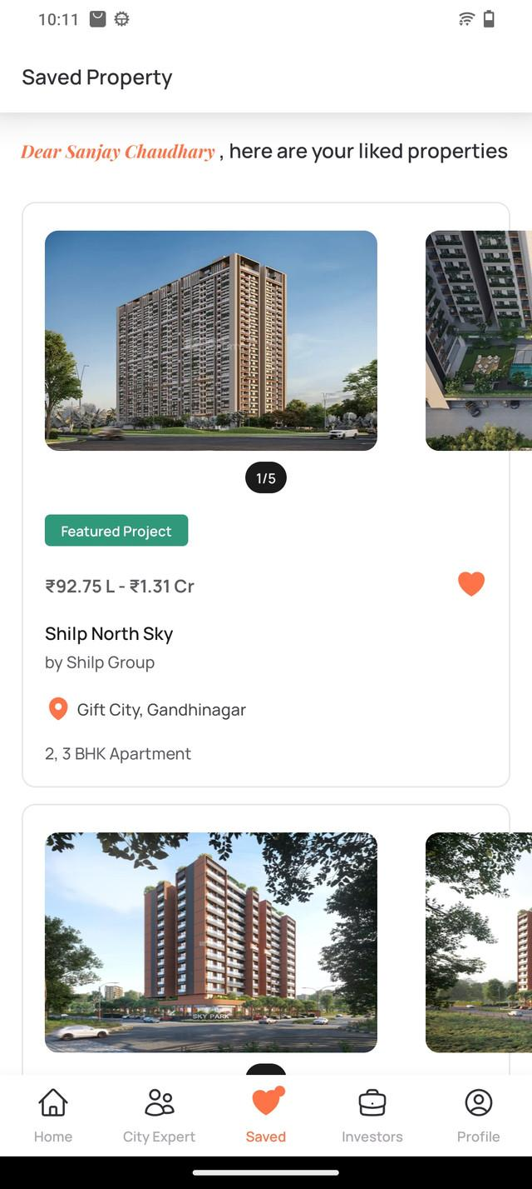

**Filter Options**

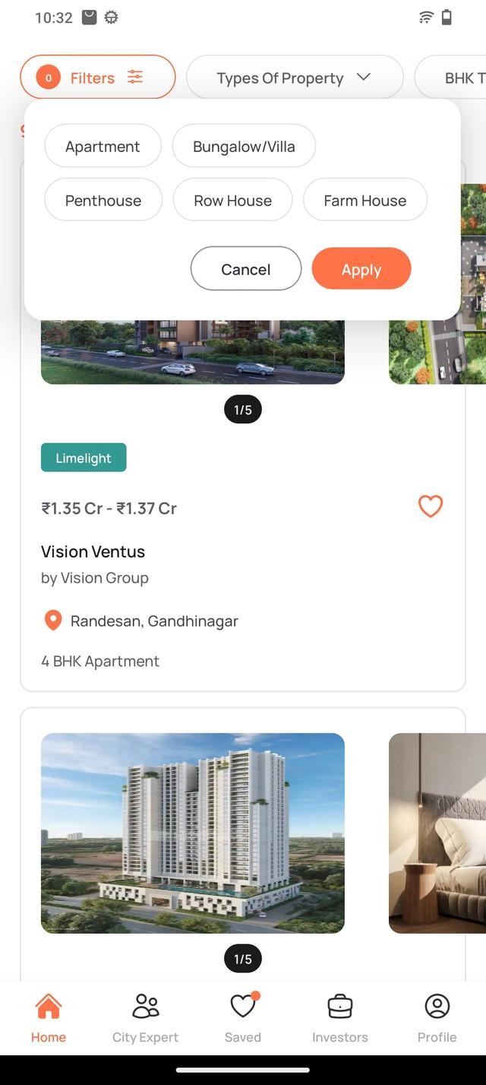

**Deliverables**

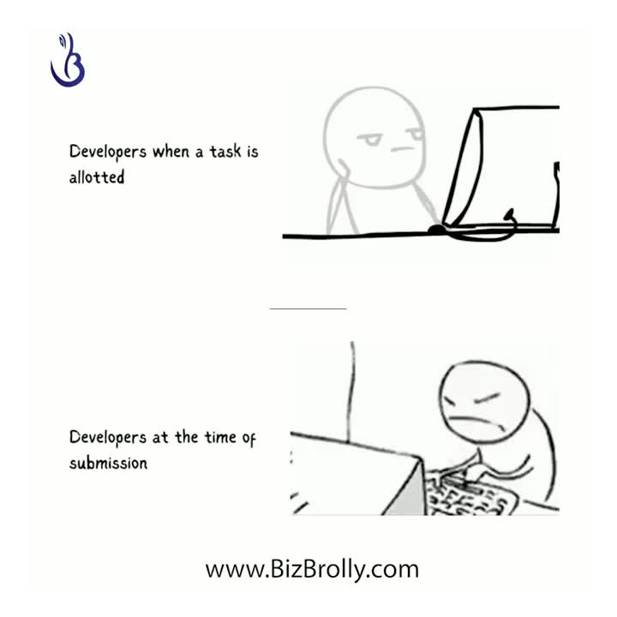

- A Public GitHub repository containing the source code of the web application

-Completion of task within the specified timeframe of one day ☝️.

Feel free to ask questions if you need clarification or additional information about any aspect of the task. Good luck! 😊

**Contact No : +91 9724246403**